Experiment No: 8

Title:
Implementation of Stack Operations (Push, Pop, Peek, Display) using Singly Linked List.

Aim:
To implement fundamental stack operations such as Push, Pop, Peek, and Display using a Singly Linked List in the C programming language.

Objectives:
- To understand the structure and behavior of a singly linked list.
- To perform stack operations using a linked list instead of arrays.
- To practice dynamic memory allocation using malloc and pointer manipulation in C.
- To build a simple and efficient LIFO (Last In First Out) data structure.

Requirements:
- Software: C Compiler (e.g., GCC)
- Hardware: Any system capable of running a C compiler
- Knowledge Prerequisites:
  - Basic understanding of C programming
  - Concepts of pointers and dynamic memory allocation
  - Understanding of stack operations
  - Knowledge of linked list structure

Description:
A stack is a linear data structure that follows the LIFO principle. In this implementation, we use a singly linked list where:
- Each node contains data and a pointer to the next node.
- The top of the stack is represented by the head of the linked list.
This report covers:
- Push: Insert element at the beginning (top of stack)
- Pop: Remove element from the beginning
- Peek: View the top element without removing it
- Display: Traverse and print all elements from top to bottom

Algorithm:

1. Push Operation (Insert element on top)
Algorithm:
- Start
- Create a new node using dynamic memory (malloc)
- If memory allocation fails:
Print "Overflow"
Exit
- Else:
Assign the value to the new node's data field
Set the new node's next pointer to the current top
Update top to point to the new node
Print "Element pushed"
- End

2. Pop Operation (Remove element from top)
Algorithm:
- Start
- If top == NULL:
Print "Underflow – Stack is empty"
Exit
- Else:
Create a temporary pointer and set it to top
Store top->data (for displaying or returning)
Update top = top->next
Free the memory of the temporary node
Print "Element popped"
- End

3. Peek Operation (View top element without removing)
Algorithm:
- Start
- If top == NULL:
Print "Stack is empty"
- Else:
Print top->data as the top element
- End

4. Display Operation (Show all stack elements)
Algorithm:
- Start
- If top == NULL:
Print "Stack is empty"
- Else:
Create a temporary pointer and set it to top
While temp != NULL:
Print temp->data
Move to next node: temp = temp->next
- End

Conclusion:
This implementation demonstrates how a singly linked list can be effectively used to perform stack operations. Unlike array-based stacks, linked list stacks offer dynamic memory allocation, meaning there is no limit on the number of elements unless system memory is full. This approach enhances flexibility and eliminates the risk of stack overflow caused by fixed sizes in arrays.

C programming Code for Stack using Linked list :
#include <stdio.h>
#include <stdlib.h>

// Node structure for stack
struct Node
{
int data; // Data of the node
struct Node* next; // Pointer to the next node in stack
};

// Pointer to the top of the stack
struct Node* top = NULL;

// Function to push an element onto the stack
void push(int value)
{
struct Node* newNode = (struct Node*) malloc(sizeof(struct Node)); // Allocate memory for new node
newNode->data = value; // Assign value to node
newNode->next = top; // Link new node to current top
top = newNode; // Update top to new node
printf("%d pushed to stack.\n", value);
}

// Function to pop an element from the stack
void pop()
{
if (top == NULL)
{ // Check for underflow
printf("Stack Underflow! Cannot pop.\n");
return;
}
struct Node* temp = top; // Store current top
printf("%d popped from stack.\n", temp->data);
top = top->next; // Move top to next node
free(temp); // Free memory of popped node
}

// Function to view the top element of the stack
void peek() {
if (top == NULL) { // If stack is empty
printf("Stack is empty.\n");
return;
}
printf("Top element is %d\n", top->data); // Print top element
}

// Function to display all elements in the stack
void display() {
struct Node* temp = top; // Start from top
if (temp == NULL) { // If stack is empty
printf("Stack is empty.\n");
return;
}
printf("Stack elements (top to bottom):\n");
while (temp != NULL) { // Traverse till the end
printf("%d\n", temp->data);
temp = temp->next; // Move to next node
}
}

// Main function: menu-driven program
int main() {
int choice, value;

while (1) { // Infinite loop for menu
// Display menu options
printf("\n--- Stack Menu ---\n");
printf("1. Push\n");
printf("2. Pop\n");
printf("3. Peek\n");
printf("4. Display\n");
printf("5. Exit\n");
printf("Enter your choice: ");
scanf("%d", &choice);

switch (choice)
{
// Execute operation based on user choice
case 1:
printf("Enter value to push: ");
scanf("%d", &value);
push(value); // Call push function
break;
case 2:
pop(); // Call pop function
break;
case 3:
peek(); // Call peek function
break;
case 4:
display(); // Call display function
break;
case 5:
exit(0); // Exit the program
default:
printf("Invalid choice! Try again.\n");
}
}

return 0;
}

Output:

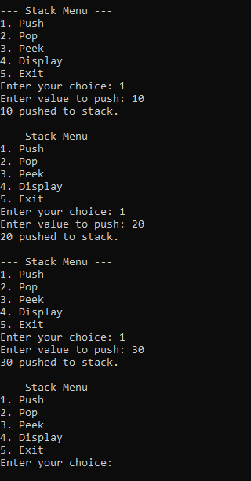
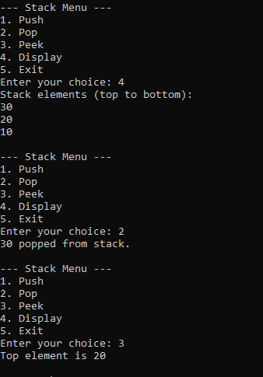

Viva Questions:
- What is a stack, and which principle does it follow?
- What is the LIFO principle?
- What is the role of the top pointer in a linked-list stack?
- What is the Push operation?
- What is the Pop operation?
- What is the Peek operation?
- Why is a singly linked list used to implement a stack?
- What is the purpose of malloc() and free() in this program?
- What is stack overflow and stack underflow?
- What is the time complexity of Push, Pop, Peek, and Display operations?

Real-Life Examples of Stack
- Stack of plates in a kitchen.
- Stack of books piled one above another.
- Undo and redo operations in text editors.
- Back button functionality in web browsers.
- Function calls in programming.
- Stack of trays in a cafeteria.
- Reversing a word or string.
- Expression evaluation in calculators.
- Checking balanced parentheses in mathematical expressions.
- Returning from nested menus in software applications.

